Chapter 1: System Design and Architecture

1.1 System Overview
The Steam Game Recommendation System is designed as a modular, object-oriented architecture that processes multi-dimensional data to generate personalized game recommendations. The system integrates user behavior analysis, review sentiment analysis, and advanced recommendation algorithms to provide accurate and trustworthy game suggestions.

1.2 Object-Oriented Programming Design

1.2.1 System Architecture Diagram
The system follows a modular architecture with five core components, as illustrated in Figure 1:
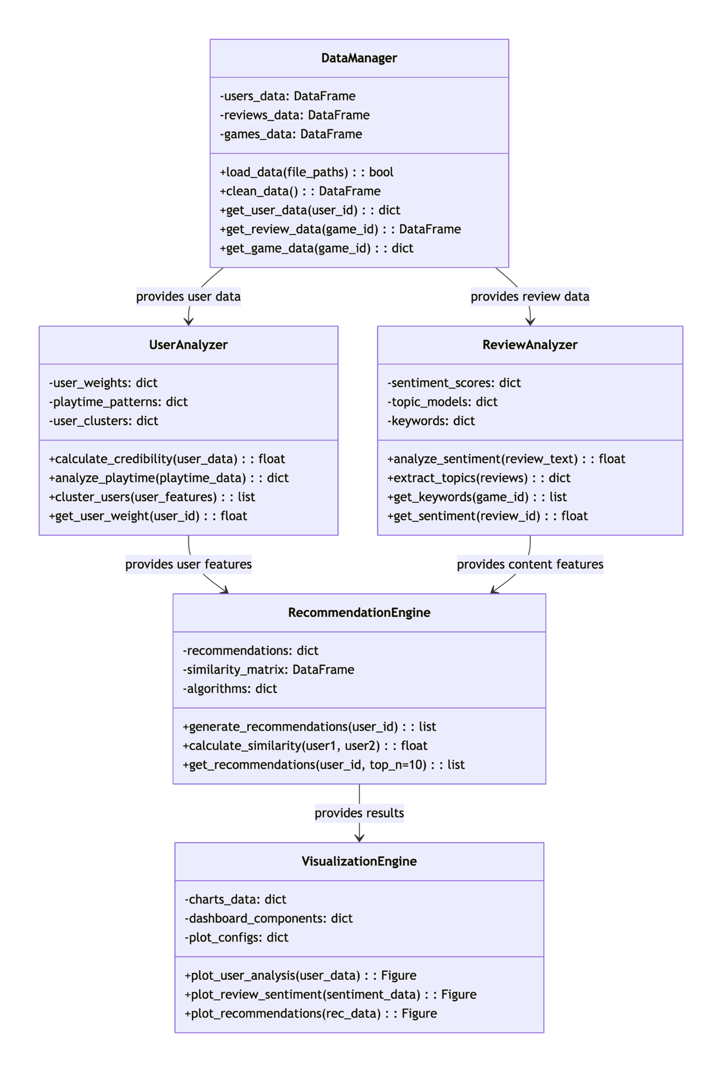
Figure 1

1.3 System Workflow
The detailed interaction between system components during a typical recommendation request is shown in Figure 2:

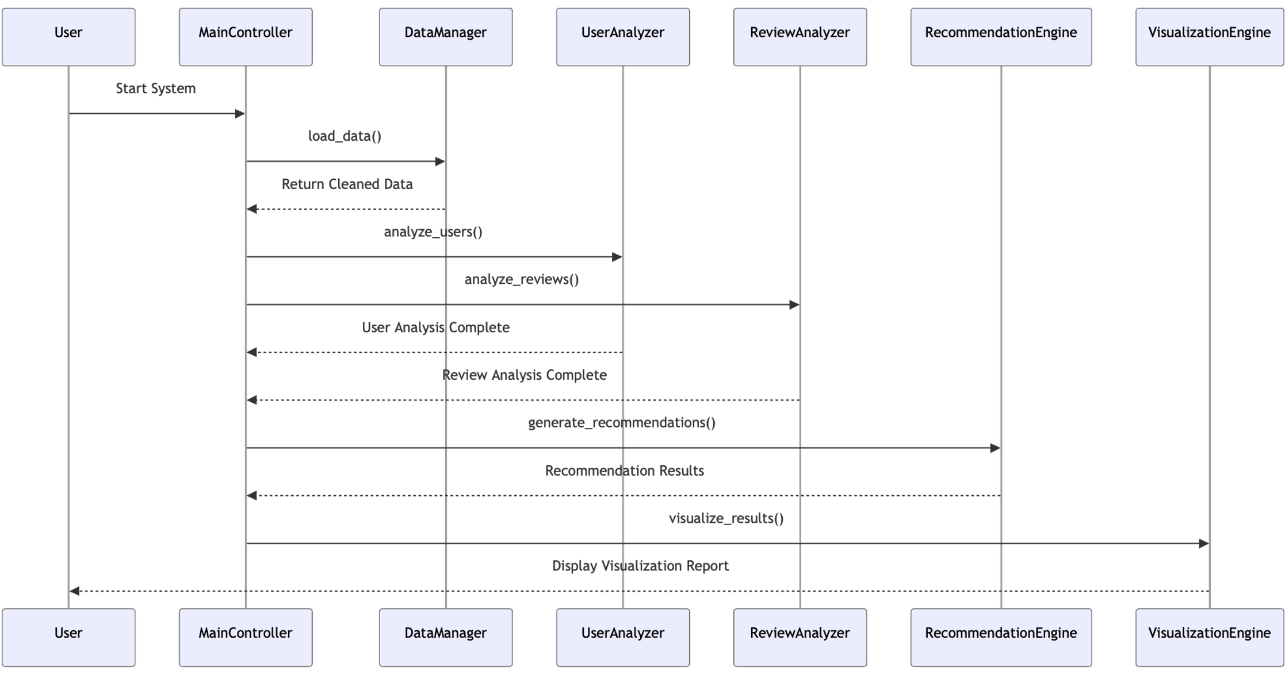
Figure 2

1.4 Module Specifications

1.4.1 Data Manager Module
Responsibilities: Data loading, cleaning, and management
- Input: Raw CSV file paths
- Output: Cleaned and structured data
- Data Flow: Provides clean data interfaces for all other modules
- Key Functions:
  - load_data(): Reads and validates input files
  - clean_data(): Handles missing values and data normalization
  - Data access methods for specific data subsets

1.4.2 User Analyzer Module
Responsibilities: User behavior analysis and credibility modeling
- Input: User game data, review data, playtime information
- Output: User weight scores, playtime patterns, user clusters
- Data Flow: Provides user feature vectors to the recommendation engine
- Key Algorithms:
  - Credibility scoring based on games owned and review helpfulness
  - Playtime pattern analysis using clustering techniques
  - User segmentation for personalized recommendations

1.4.3 Review Analyzer Module
Responsibilities: Sentiment analysis and topic extraction from review content
- Input: Review text, recommendation labels
- Output: Sentiment scores, topic distributions, keywords
- Data Flow: Provides content features for the recommendation system
- NLP Techniques:
  - Sentiment analysis using pre-trained models
  - Topic modeling with LDA (Latent Dirichlet Allocation)
  - Keyword extraction for feature identification

1.4.4 Recommendation Engine Module
Responsibilities: Generating personalized game recommendations
- Input: User features, game features, review features
- Output: Recommended game lists with similarity scores
- Data Flow: Integrates all analysis results to generate final recommendations
- Algorithms Implemented:
  - Collaborative filtering based on user similarities
  - Content-based filtering using game features
  - Hybrid approach combining multiple methods

1.4.5 Visualization Engine Module
Responsibilities: Data visualization and result presentation
- Input: Analysis results, recommendation results
- Output: Charts, dashboards, report visualizations
- Data Flow: Retrieves data from analysis modules for visualization
- Visualization Types:
  - User behavior analytics charts
  - Sentiment distribution plots
  - Recommendation result displays

